Facial Expressions

In American Sign Language, facial expressions are an important part of communication.  
The facial expressions you use while doing a sign will affect the meaning of that sign.   
For example, if you sign the word "quiet," and add an exaggerated or intense facial expression, you are telling your audience to be "*very* quiet."   
This principle also works when making "interesting" into "very interesting," or "funny" into "very funny."   
Facial expressions are an example of a set of behaviors called "non-manual markers."  Non-manual markers include facial expressions, head tilt, head nod, head shake, shoulder raising, mouth morphemes, and other non-signed signals that influence the meaning of your signs.

On side how facial expressions can affect the simple sign "YOU."

This version of YOU is actually a question.    
"Is it you?"  
"Are you ... ?"  
"Did you?"  
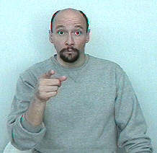

Suppose you wanted to say, "It's *you?!*?!  I wouldn't have thought that it would be you! I'm surprised by that."  
You can say all that with just one sign by using appropriate facial expressions:  
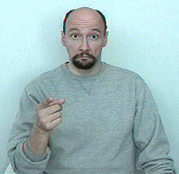  
See an animation for this sign:  "[YOU](http://www.lifeprint.com/asl101/gifs-animated/you-somewhatsurprised.gif)" (surprised that it is you)